Apache User’s Guide
文件編號： | 版本：
SW名稱： | 專案號碼：

核准： |  | 審核： |  |  | 撰寫： |  | 發 行 章
相 關 單 位 會 簽

文件變更履歷：
版本 | 修訂內容 | 修訂原因 | 日期 | 修訂者
V1.0 | Create |  | 2006/01/24 | AceLan Kao
V1.1 | Support for UC+, IA-24X, W3XX, UC-7112 Plus |  | 2008/05/12 | Johnson Liu

1. Introduce Apache 4
1.1. What is Apache? 4
1.2. What is the Apache HTTP Server? 4
1.3. How thoroughly tested is Apache? 4
2. Release Packages 4
3. Simple Users’ Guide 4
3.1. Install Apache(720KB) 5
3.2. Install Apache + PHP(7.3MB) 6
3.3. Install Apache + SSL + PHP(7.3MB) 6
3.4. Uninstall Apache 8
3.5. Exit 8
4. How to Test 8
4.1. Apache 8
4.2. Apcahe + PHP 9
4.3. Apache + SSL + PHP 10
5. Reference 11

Introduce Apache

What is Apache?
The Apache Software Foundation (ASF) is a 501(c)3 non-profit organization providing support for the Apache community of open-sourced software projects. For more details, please see the Apache Software Foundation FAQ
The Apache HTTP Server -- sometimes called Apache httpd -- is a project of the Apache Software foundation aimed at creating a robust, commercial-grade, featureful, and freely-available source code implementation of an HTTP (Web) server. For more information, please see the About Apache page.

What is the Apache HTTP Server?
- is a powerful, flexible, HTTP/1.1 compliant web server
- implements the latest protocols, including HTTP/1.1 (RFC2616)
- is highly configurable and extensible with third-party modules
- can be customised by writing 'modules' using the Apache module API
- provides full source code and comes with an unrestrictive license
- runs on Windows 2003/XP/2000/NT/9x, Netware 5.x and above, OS/2, and most versions of Unix, as well as several other operating systems
- is actively being developed
- encourages user feedback through new ideas, bug reports and patches

How thoroughly tested is Apache?
Apache is run on millions of Internet servers. It has been tested thoroughly by both developers and users. The Apache HTTP Server Project maintains rigorous standards before releasing new versions of our server, and our server runs without a hitch on over 70% of all WWW servers available on the Internet. When bugs do show up, we release patches and new versions as soon as they are available.

Release Packages
No | Filename | Description
1 | apache-1/ | Configuration files for pure web server only.
2 | apache-2/ | Configuration files and modules for apache, SSL, and PHP.
3 | apache | Start script for pure web server.
4 | apachectl | Start script for apache + SSL + PHP.
5 | httpd-1 | Binary execution file for pure web server.
6 | httpd-2 | Binary execution file for apache + SSL + PHP.
7 | httpd.conf | Apache configuration file support SSL.
8 | Install.sh | Installation script
9 | libapr-1.so.0 | Library for apache
10 | libaprutil-1.so.0 | Library for apache
11 | libexpat.so.0 | Library for apache
12 | libjpeg.so.62 | Library for PHP
13 | libm.so.6 | Library for apache and PHP
14 | libmysqlclient.so.14.0.0  or  libmysqlclient.so.15.0.0  or  libmysqlclient.so.16.0.0 | Library for MySQL
15 | libpng.so.2 | Library for PHP
16 | libxml2.so.2 | Library for PHP
17 | php.ini | Configuration file for PHP
18 | phpinfo.php | PHP info web page
19 | ssl_keygen.sh | SSL key generation script

Simple Users’ Guide
The following users’ guide will describe how to install simple web server, web server with PHP support, web server with SSL and PHP support, and how to remove web server from Moxa embedded computer.
PHP module already compiled with MySQL, you don’t need to install MySQL client library before using PHP + MySQL, if you haven’t installed MySQL client, you will get a copy of ‘libmysqlclient.so.14.0.0, libmysqlclient.so.15.0.0 or libmysqlclient.so.16.0.0’ after installing.
Before starting installation/uninstallation acpache, we suggest you upload apache.tgz to a ramdisk on Moxa embedded computer, please follow the statements bellow.
- Using command ‘upramdisk’ to mount a ram disk at ‘/mnt/ramdisk’ and copying the apache package to ‘/mnt/ramdisk’ on Moxa embedded computer.
(If you have another linux box and has ssh server installed already, you can use ‘scp’ to copy files as the following screenshots, else you can using ftp to transmit file. Each Moxa embedded computer series box has ftp server/client installed.)

192.168.30.126 - Putty
root@Moxa:/mnt/ramdisk# tar xzvf apache-sdlinux.tgz
apache-sdlinux
apache-sdlinux/apache-2
apache-sdlinux/apache-2/magic
apache-sdlinux/apache-2/mime.types
apache-sdlinux/apache-2/openssl.cnf
apache-sdlinux/apache-2/ssl_keygen.sh
apache-sdlinux/apache-2/conf
apache-sdlinux/apache-2/conf/httpd.conf
apache-sdlinux/apache-2/extra

- After that, untar the apache package and enter its directory. Running ‘install.sh’ script you will see five selections, we will describe these five selections bellow.

192.168.30.126 - Putty
root@Moxa:/mnt/ramdisk# cd apache-sdlinux
root@Moxa:/mnt/ramdisk/apache-sdlinux# ./install.sh
Choose:
1. Install Apache.
2. Install Apache + PHP.
3. Install Apache + SSL + PHP.
4. Uninstall Apache.
5. Exit.

Install Apache(720KB)
- In Moxa embedded computer series box, it already installed a simple apache web server, you don’t need to choose this selection, if you had not modified any apache settings or removed it.
- Choosing ‘1’ to install a pure web server, it will stop the existing web server first, install apache web server, and then restart the web server. After seeing the prompt text again, the new web server has installed and has been restarted again.
- After install the web server, please do not forget to modify the configuration file ‘/etc/apache/httpd.conf’ for your environment.
192.168.30.126 - Putty
root@Moxa:/mnt/ramdisk# cd apache-sdlinux
root@Moxa:/mnt/ramdisk/apache-sdlinux# ./install.sh
Choose:
1. Install Apache.
2. Install Apache + PHP.
3. Install Apache + SSL + PHP.
4. Uninstall Apache.
5. Exit.
2
Installing, Please wait..........
Install successful..

Starting web server: apache

root@Moxa:/mnt/ramdisk/apache-sdlinux#

Install Apache + PHP(7.3MB)
  - PHP is a very powerful server-side script, if you need web server with PHP support, choose selection ‘2’.
  - Choosing ‘2’ to install a web server with PHP support, it will stop the existing web server first, install apache web server, and then restart the web server. After seeing the prompt text again, the new web server has installed and has been restarted again.

192.168.30.126 - Putty
root@Moxa:/mnt/ramdisk# cd apache-sdlinux
root@Moxa:/mnt/ramdisk/apache-sdlinux# ./install.sh
Choose:
1. Install Apache.
2. Install Apache + PHP.
3. Install Apache + SSL + PHP.
4. Uninstall Apache.
5. Exit.
2
Installing, Please wait..........
Install successful..

Starting web server: apache

root@Moxa:/mnt/ramdisk/apache-sdlinux#

Uninstall Apache
If you don’t need any web service, choosing the selection ‘4’ to uninstall the web server(including the default web server)

192.168.30.126 - Putty
root@Moxa:/mnt/ramdisk/apache-sdlinux# ./install.sh
Choose:
1. Install Apache.
2. Install Apache + PHP.
3. Install Apache + SSL + PHP.
4. Uninstall Apache.
5. Exit.
4
Uninstalling, Please wait...
Stop daemon..
httpd: Could not reliably determine the server's fully qualified domain name, using 192.168.3.127 for ServerName
Uninstall successful..

root@Moxa:/mnt/ramdisk/apache-sdlinux#

Exit
If you just want to take a look, and do not want to make any modification, you can choose the selection ‘5’ to exit, safely. This selection will not do any modification.

How to Test

Apache
- Opening a browser and keyin the IP address of Moxa embedded computer as the URL, you should see a “Test Page” shown on browser.
- If there isn’t shown any page, you have some methods to check what happens.
    - Using command ‘ps ax | grep httpd’ to check if there are httpd processes running at background. If there are httpd processes running, but browser shown nothing, you might lose the index page, try to write one by yourself and put it in the directory ‘/usr/www/html/’.
    - If there isn’t any httpd process running, try to start the web server by ‘/etc/init.d/apache start’
    - If you still can’t make the web server work, try to upgrade firmware and reinstall again.
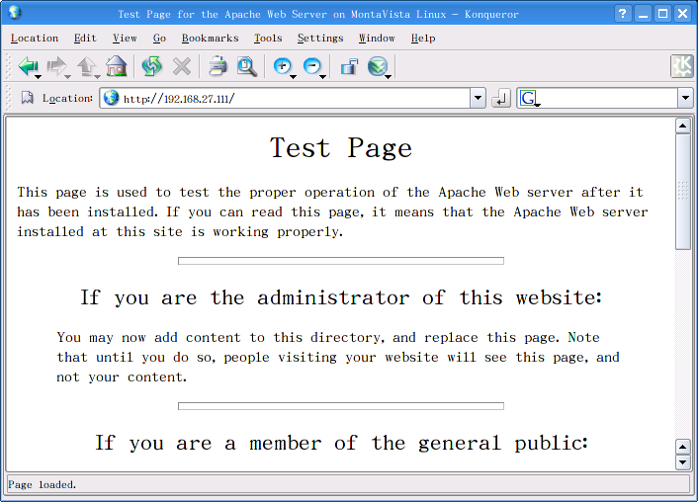

Apcahe + PHP
- After installing Apache + PHP, you also get a copy of phpinfo.php in the directory ‘/usr/www/html’. It will help you to check if PHP works or not, and it also show many PHP settings, these information is very important when you develop your web pages by PHP.
- Just opening http://EmbeddedComputer-IP/phpinfo.php, you will see the PHP information shown on the browser.
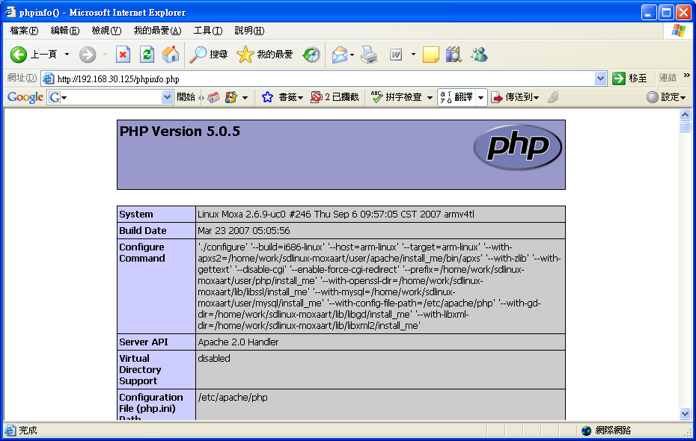

Reference
- Apache HTTP Server Official Website - http://httpd.apache.org/
- PHP Official Website - http://www.php.net/
- OpenSSL Official Website - http://www.openssl.org/
- mod_ssl Official Website - http://www.modssl.org/
- MySQL Official Website - http://www.mysql.com/

